 **THE WESTMINSTER SCHOOL, DUBAI**

**SUBJECT: MATHEMATICS YEAR: 2**

**TOPIC: Shapes**

1. Identify and describe the properties of 2D shapes, including the number of sides and line symmetry in a vertical line.

Name these shapes and describe their properties.

4

0

4

1

Diamond

Circle

**a)** Name of shape

**b)** Name of shape

Number of sides

Number of sides

Number of corners

Number of corners

1. Draw one line of symmetry through the following shapes.

**c)**

**d)**

1. Identify 2D shapes on the surface of 3D shapes.

Match the 3D shape to the 2D shapes which form its faces.

|  |  |
| --- | --- |
| cube | rectangles |
| cuboid | Squares |

1. Identify and describe the properties of 3D shapes, including the number of edges, vertices and faces.

Name these shapes and fill in the properties.

Cuboid

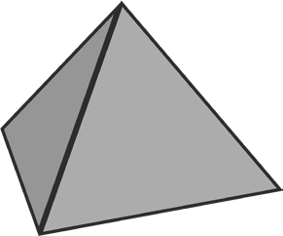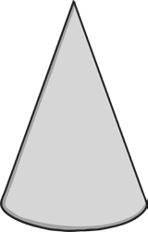

**c)** I am thinking of a 3D shape. It has 6 faces: 2 squares and 4 rectangles. It has 8 vertices. Tick the shape I am describing.

Can you tell me what it is called?

0

6

2

9

3

5

Cylinder

Triangular prism

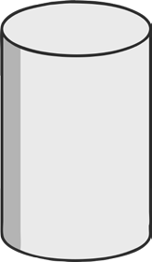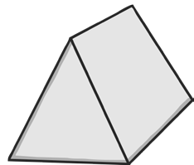

**a)** Name of shape

**b)** Name of shape

Number of faces

Number of faces

Number of edges

Number of edges

Number of vertices

Number of vertices

1. Compare and sort common 2D and 3D shapes and everyday objects.
2. Tell me one thing that is the same and one thing that is different about these 2

shapes.

Hexagon Equilateral triangle

Same 2D shapes

Different sides